Full Lace Wig Order Form
Change as Needed – What is marked below are the standard answers.
Reseller Name: ID# ________ Order Date: _______ Product Code: ____________
Hair Type : 100% Indian Remy Human Hair
Hair Texture: [ ] As picture
Hair Length : [ ] Full wig all over
Hair Color : Base Color: # Highlight Color: # (if applicable) Equally Blended [ ] or Highlighted [ ]
If Highlighted – At what Mix Rate Your Choice Here [ ] 70-30% is Typical
Hair Density : Your Choice Here [ ] Medium (is typical) or [ ] As picture:
Bleach knot : Yes [ ] Full head
Baby Hair: Yes [ ] Around Perimeter Baby Hair Type: [ ] curly Baby hair
Type of Knots : Yes [ ] Double Knots
Hair Style: Yes [ ] Free Style – Part Anywhere

Cap Design
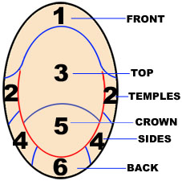 | Cap Design  [ ] Lace Front Wigs  [ ] Full Lace Wigs  [ ] Lace around the head, With Stretch Lace from top to nape.  [ ] Lace around the head , With a little Stretch Lace From ear to ear.  [ ] Lace around the head，with Thin Skin Top.  [ ] Without Stretch Lace.  [ ] Thin Skin Wigs NG Base  Lace Color [ ] Transparent  Lace Type  Other
Cap Size (Measurements below in Inches)
[ ] Extra Large [ ] Large [ ] Medium [ ] Small [xxx] Customized (See Measurements)
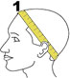 Circumference 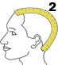 Front to Nape 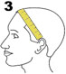 Ear to ear across forehead 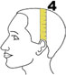 Ear to ear over top 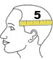 Temple to temple round back 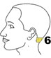 Nape of Neck

Size Measurements | 1. | 2. | 3. | 4. | 5. | 6.
Put Answers in Box Below numbers.

